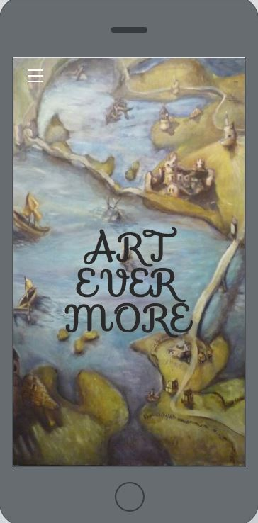
Teaching From Your Website – Virginia Murphy
Working Digitally
Teaching from your website has pros and cons. As the practice of teaching continues to incorporate new technologies, so should teachers. While building the website might be time consuming, it can permit accountability, efficiency and advocacy in a 21st century learning environment.
Pros | Cons
Accountability | Initial Prep
Efficiency | Internet Reliance
21st Century Resources | Blocks

Living Without Worksheets

Process: The How To Guide
While I am biased towards Weebly, here are a few videos on my favorite web builder
along with Wix and Google Sites
Please go to
artevermore.weebly.com/teaching-from-your-website.html
for presentation
Keep Your Head Above Water: Don't Reinvent the Wheel
Your website should be an AMALGAMATION of resources, i.e. you should use a variety of resources to teach your assignments.
Some strategies you can use that also reflect scaffolding:
- Uploading found tutorials for different art processes and concepts (introductory)
- Creating a list of key search terms for students to use (experimentation)
- Via a list of constraints, students research, design and create a project (proficiency)
- Student initiate a series or personal project that involves research, design, creation and context within the art world ( mastery)

Double Dip
Does your school have a program already in place that they want you to use? You can still use your website by copy pasting information from your website into this resource.

Digital Advocacy
Your website can be shared outside of your classroom as a reflection of your classroom environment and advocate for your content area. One way I like to advocate for my discipline is include links to the relevant standards within my unit. While parents, students, administrators see the same page, each finds the information they are looking for.

Creating a Culture of Student Independence and Self Advocacy
In a culture of digital transparency all students should learn the effects of positive and negative online presence. Creating an artist portfolio that students maintain from introductory to higher levels of Art not only helps online presence, but also helps students in preparation for art careers after high school.

